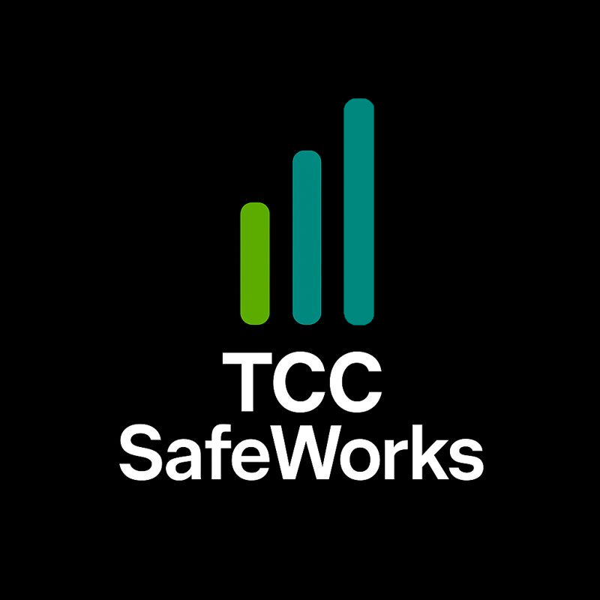

TCC SafeWorks™ is built on a three-phase model: Safety, Training, and Operations.
Safety is the foundation of all work and must be satisfied before training or operations begin. Training ensures personnel are qualified and competent for assigned tasks. Operations represent authorized execution of work once safety and training requirements are met.

TCC SafeWorks™
Safety Training & Authorization Program

The Controls Company, LLC
Program Title: TCC SafeWorks™ Safety Training & Authorization Program
Framework: Safety → Training → Operations
Revision: 1.0
Effective Date: __________________

Program Overview
TCC SafeWorks™ is The Controls Company’s internal safety training and authorization program. The purpose of this program is to ensure that all employees performing work activities are trained, evaluated, and authorized in a manner consistent with OSHA regulations, applicable ANSI standards, manufacturer requirements, and industry best practices.
The SafeWorks™ program is built on a three-phase model:
- Safety – Identification and control of hazards, jobsite conditions, and protective requirements.
- Training – Classroom instruction, hands-on practice, and demonstration of competence.
- Operations – Formal authorization to perform work once safety and training requirements are satisfied.
No work activity may advance to the Operations phase unless Safety and Training requirements have been fully met.
This program applies to all TCC employees, subcontractors (where applicable), and work activities requiring task-specific safety training or authorization.

Instructor Authority Statement
Training under the TCC SafeWorks™ program shall be conducted by a Qualified Person, as defined by OSHA and applicable ANSI standards.
A Qualified Person is one who, by possession of a recognized degree, certificate, professional standing, or by extensive knowledge, training, and experience, has demonstrated the ability to train employees, identify hazards, and evaluate safe work practices for the applicable task or equipment.
Instructors are authorized by The Controls Company to:
- Deliver classroom and field training
- Administer written or verbal knowledge assessments
- Conduct hands-on practical evaluations
- Determine pass/fail status
- Recommend authorization, retraining, or revocation of authorization
Final authorization to operate equipment or perform controlled work activities rests with TCC management.

Training Matrix
The Training Matrix defines which SafeWorks™ modules are required for specific roles and activities. Modules may be added as company operations expand.
Employee Role | Safety Orientation | MEWP (Scissor) | MEWP (Boom) | Fall Protection | LOTO | Electrical Safety | Other Modules
Field Technician | ✔ | ✔ | ✔ | ✔ | ✔ | ✔ | As Required
Apprentice | ✔ | ✔ | ☐ | ✔ | ✔ | ✔ | As Required
Project Manager | ✔ | ☐ | ☐ | ✔ | ✔ | ✔ | As Required
Supervisor / Lead | ✔ | ✔ | ✔ | ✔ | ✔ | ✔ | As Required
Authorization is task- and equipment-specific and must be documented.

TCC SafeWorks™ Module: MEWP (Scissor & Boom Lifts)
Module Scope
This module applies to the operation of Mobile Elevating Work Platforms (MEWPs), including:
- Scissor Lifts (MEWP 3A)
- Boom Lifts – Articulating and Telescoping (MEWP 3B)

Safety Phase
- Review manufacturer operator manuals and decals
- Identify jobsite hazards (surface conditions, overhead obstructions, power lines, weather, traffic)
- Verify PPE and fall protection requirements
- Review stop-work authority and emergency procedures

Training Phase
Classroom Instruction
- MEWP types and classifications
- Load capacities and stability
- Pre-use inspections and function testing
- Fall protection requirements
- Safe travel and positioning
- Emergency lowering and rescue procedures
Hands-On Training
- Machine startup and shutdown
- Driving and steering
- Elevating and lowering
- Deck extension use (scissor lifts)
- Swing and outreach awareness (boom lifts)
- Ground control operation

Evaluation Phase
Each operator must demonstrate competence through a practical evaluation conducted by a Qualified Person. Evaluation includes:
- Pre-use inspection
- Safe operation
- Emergency stop and lowering
- Hazard recognition
Operators who do not demonstrate competence shall receive additional training prior to re-evaluation.

Operations Authorization
Upon successful completion of Safety and Training phases, the employee may be issued MEWP Operator Authorization under the TCC SafeWorks™ program.
Authorization is valid only for the equipment types listed and may be revoked if unsafe behavior, incidents, or significant changes in work conditions occur.

Future Modules (Reserved)
The following modules may be added under the TCC SafeWorks™ framework:
- Fall Protection
- Lockout / Tagout (LOTO)
- Confined Space Entry
- Electrical Safety / Arc Awareness
- Hot Work
- Site-Specific Hazard Training
Additional modules shall follow the same Safety → Training → Operations structure defined in this program.

